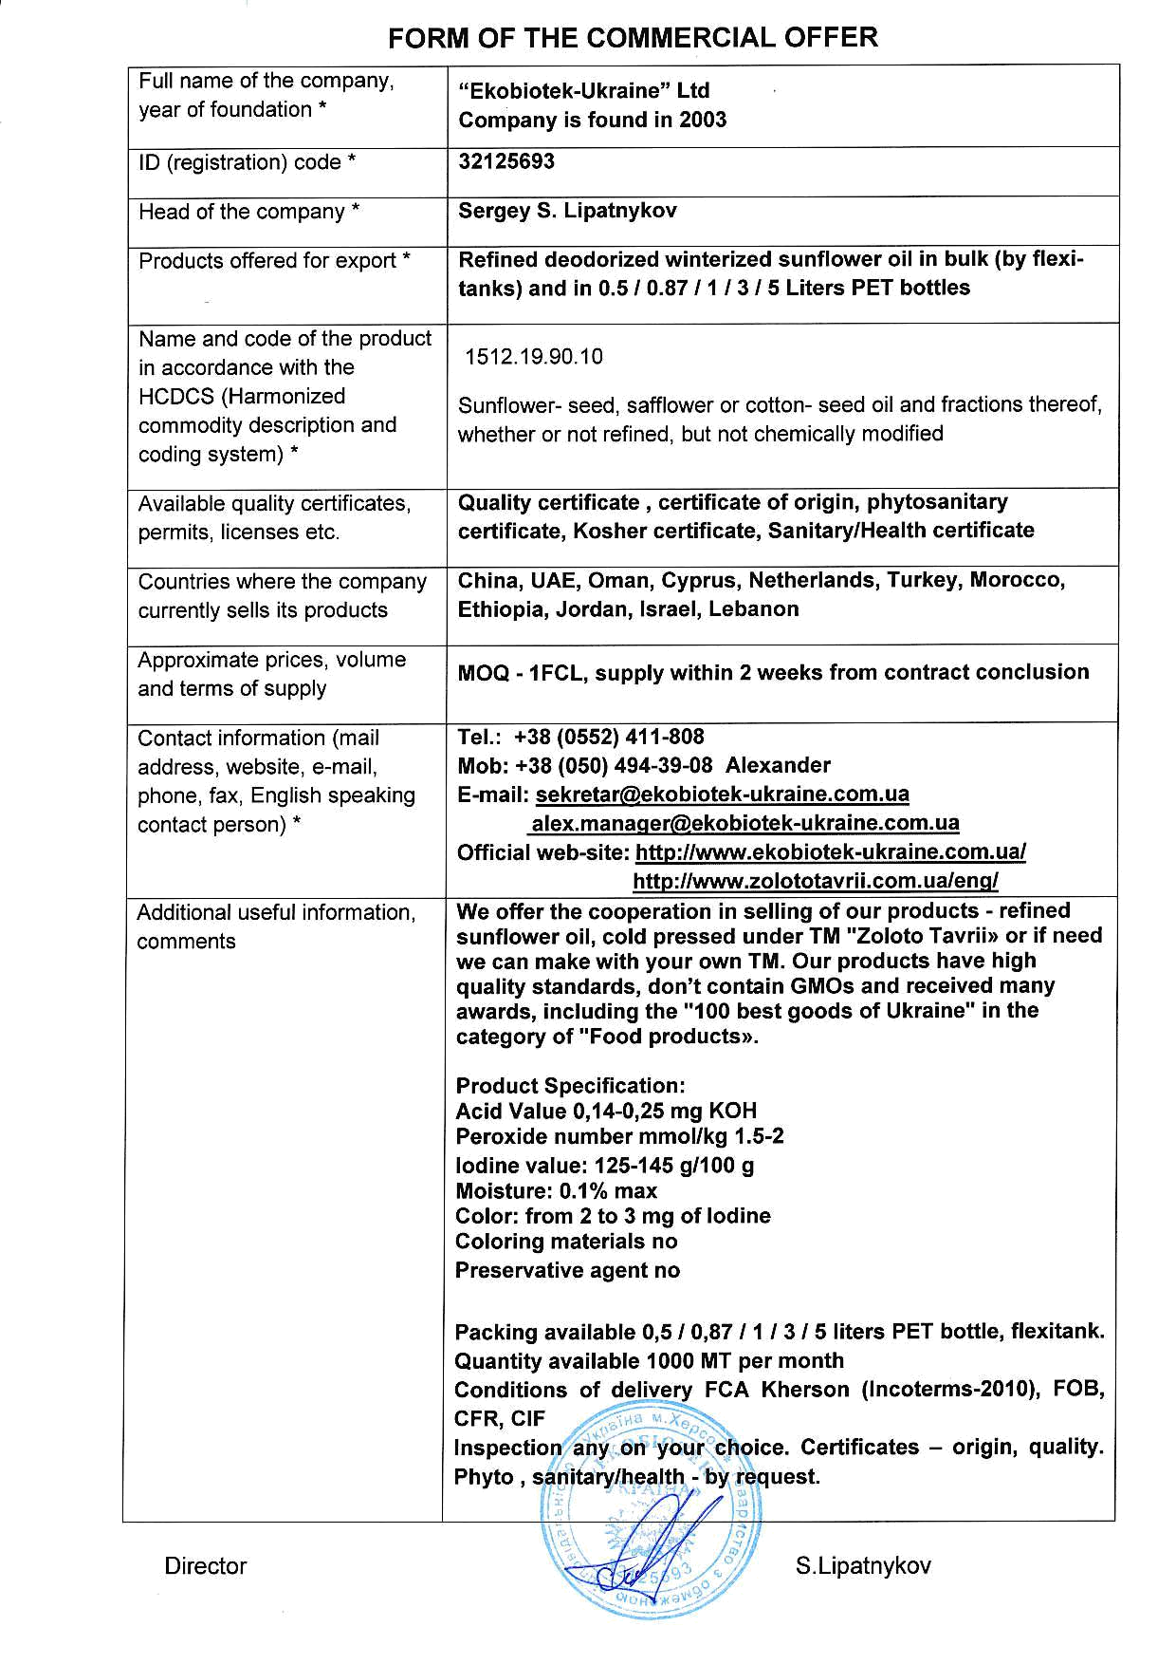
FORM ОF ТНЕ COMMERC|AL ОFFЕR

Fчll name of the соmрапу, _{уеаr} of foundation *

lD (registration) code *

Head of the соmрапу *

Рrоdчсts offered fоr ехроrt *

Name and code of the product

in accordance with the HcDcS (Harmonized

commodity deScription and coding ýystem) ^{t}

Available quality certif icates, permits, licenses etc,

countries Whеrе the соmрапу

счrгепtlу Sells itý products

Аррrохimаtе prices, volUme апd tеrms of Supply

contact information (mail address, Website, e-majl, _{рhопе,} fax, English Speaking contact _{реБоп)} *

"Ekobiotek-Ukraine" Ltd Соmрапу is found in 2003

з212569з

Sergey S. Lipatnykov

Refined deodorized winterized sunflower oil iп bulk (Ьу flexb tanks) and iп 0"5 / 0.87 / 1 / 3 / 5 Liters РЕТ bottles

1512.19.90,10

sunflower- seed, safflower оr cotton- seed oil and fractions thereof,

Whether оr поt refined, but not chemically modified

Quality certificate , certificate of origin, phytosanitary certificate, Коshеr certificate, Sanitary/Health certificate

china, UAE, Оmап, Сурrus, Nether|ands, Тчrkеу, Morocco,

Ethiopia, Jordan, lsrael, LеЬапоп

МОQ - ^{,lFcL,} sцррlу Within 2 weeks from contract conclusion

Tel.: +З8 (0552) 411_808

моЬ: +38 (050) 494_з9-08 Alexander
^{E-maili} ý9КI9!з!@gК9!Ф!еtд!Еjд.9д9
alex.manaqer@ekobiotek-ukraine.com.ua
officialweb-site:@
http://wwwzolototavria,com. ца/епq/

Additional useful iпfоrmаtiоп,

соmmепts

We оffег the Gooperation iп selling of очr products - refined

sчпflоWеr oil, cold presýed under ТМ "zoloto Tavrii)D оr if пееd we сап make With your оWп ТМ. Очl products have high
quality ýtandards, don't contain GMoý апd received mапу

awards, including the "'|00 best goods of Ukraine" in the category of "Food producbD.

Product Specification ;
Acid value 0,14-0,25 mg КОН
Peroxide пumЬеr mmoukg 1.5-2 lodine чаlче: ^{,|25-145} g/100 g Moisturei 0.1% mах
color: from 2 to 3 mg of lodine

coloring materials по Preservative agcnt по

Packing available 0,5 / 0,87 /'l / З / 5 liters РЕТ bottle, flexitank. Quantity available 1000 МТ per month
conditions of delivery FсА кhеrsоп (lncoterms-2o10), FОВ,
cFR, сlF
lnspecti lce. cedificates - origin, quality,
Phyto ,

/ /1/

Director _{-цL{} ,, S.Lipatnykov

